Kubernetes Task 7
Task 1: Execute all yaml files shown in video.
Task 2: Taint a Node and Schedule a Tolerant Pod Taint a node with special=true:NoSchedule. Create a pod with a toleration that matches the taint, allowing it to be scheduled on the tainted node.
Task 3: Use NodeSelector to Schedule a Pod on a Specific Node Label a node with env=dev. Create a pod with a nodeSelector that schedules it only on the node labeled env=dev.
Task 4: Use Node Affinity with Soft Scheduling Label a node with env=test. Create a pod with PreferredDuringSchedulingIgnoredDuringExecution node affinity, preferring to schedule it on a node labeled env=test. Remove the label and verify the pod continues to run.
Task 5: Implement Node Affinity with Hard Scheduling Create a pod with RequiredDuringSchedulingIgnoredDuringExecution node affinity, ensuring it will only be scheduled on a node labeled env=prod. Verify the pod cannot be scheduled if no node has the env=prod label.
Task 6: Taint a Node and Use NoExecute with Toleration Seconds Taint a node with special=true:NoExecute. Create a pod with a tolerationSeconds field (e.g., 60 seconds) and observe it gets evicted after 60 seconds on the tainted node.

Step 1 — Taint Worker 1
Run:
kubectl taint nodes ip-172-31-10-231 special=true:NoSchedule
You should get:
node/ip-172-31-10-231 tainted
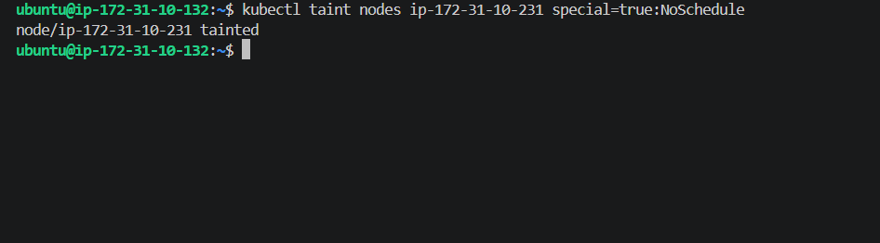
We added this taint:
special=true:NoSchedule
Meaning:
- special → taint key
- true → taint value
- NoSchedule → effect
NoSchedule means new pods that don't tolerate this taint should not be scheduled onto this node.
Step 2 — Verify the taint
Run:
kubectl describe node ip-172-31-10-231 | grep Taints
Expected:
Taints: special=true:NoSchedule

Step 3 — Create the tolerant Pod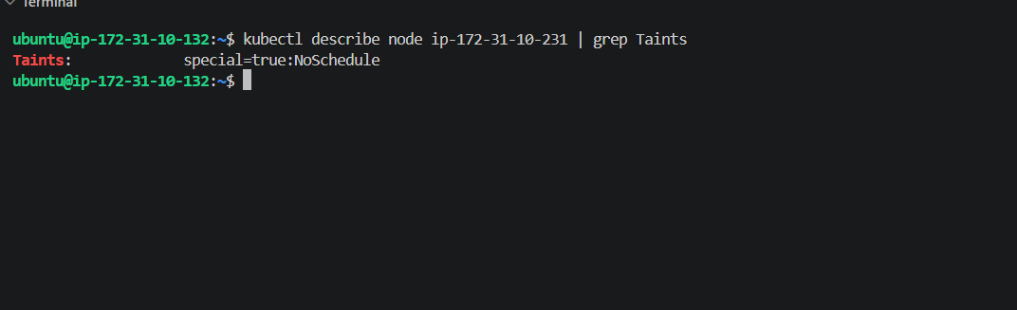
Run:
vi tolerant-pod.yaml
Paste exactly this:
apiVersion: v1
kind: Pod
metadata:
name: tolerant-pod
spec:
containers:
- name: nginx
image: nginx
tolerations:
- key: "special"
operator: "Equal"
value: "true"
effect: "NoSchedule"
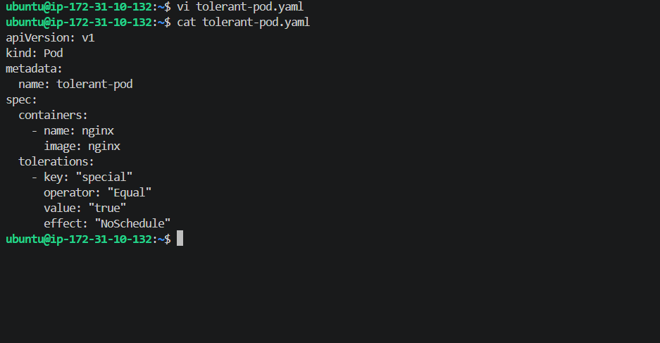
Step 4 — Create the Pod
Run:
kubectl apply -f tolerant-pod.yaml
Expected:
pod/tolerant-pod created
Step 5 — Check Pod status
Run:
kubectl get pods
Wait until you see:
tolerant-pod 1/1 Running
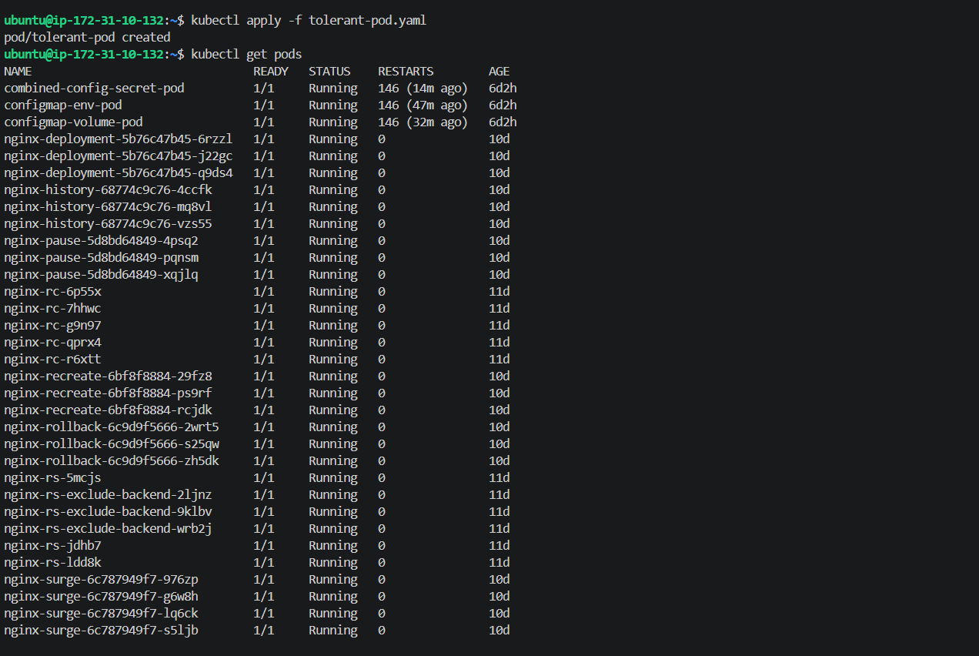
Step 6 — Most important verification
Run:
kubectl get pods -o wide
Look at the NODE column.
We want:
tolerant-pod ... ip-172-31-10-231
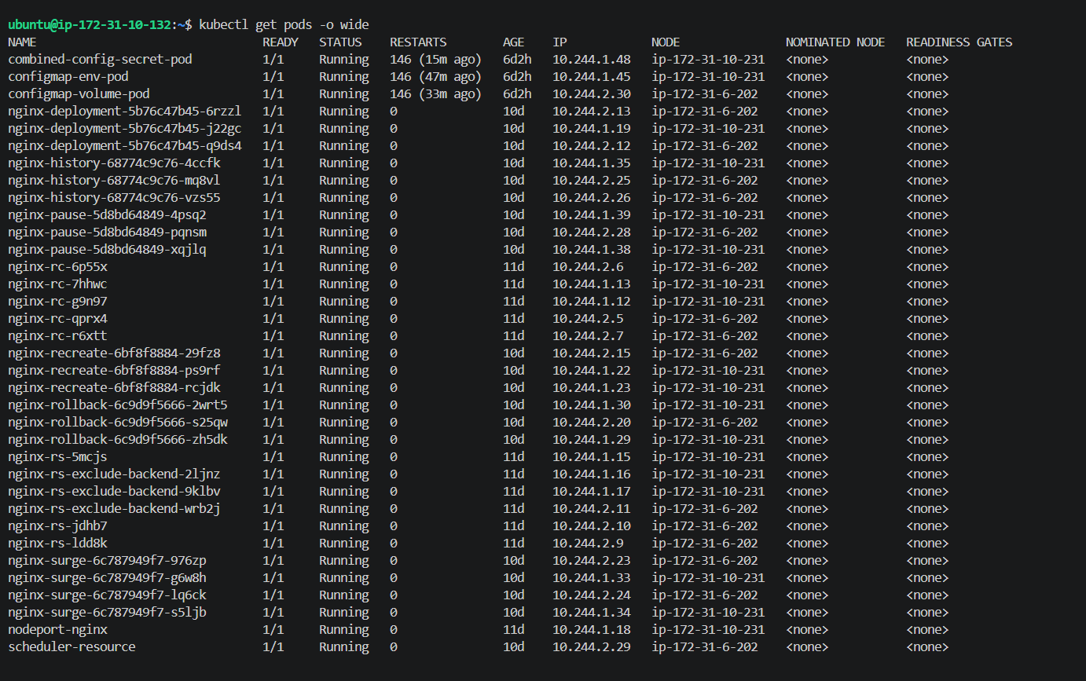
Task 3 — Step 1
We'll use your other worker:
ip-172-31-6-202
Run:
kubectl label nodes ip-172-31-6-202 env=dev
Expected:
node/ip-172-31-6-202 labeled
Then verify:
kubectl get nodes --show-labels
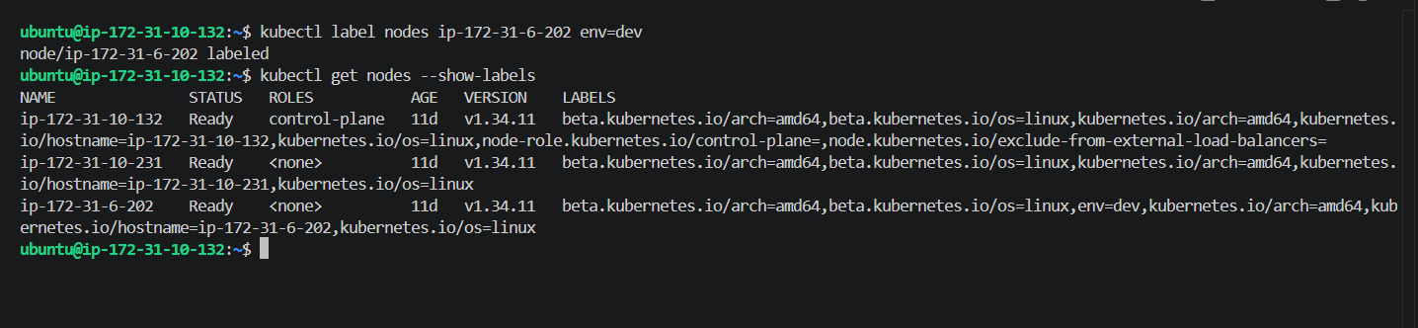
Task 3 — Step 2: Create the NodeSelector Pod
Now create the YAML:
vi nodeselector-pod.yaml
Paste this exactly:
apiVersion: v1
kind: Pod
metadata:
name: dev-pod
spec:
containers:
- name: nginx
image: nginx
nodeSelector:
env: dev
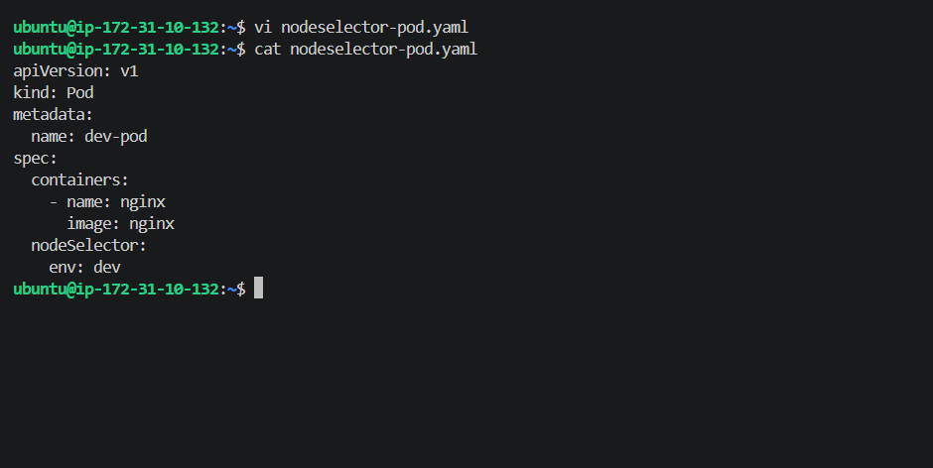
Then apply it:
kubectl apply -f nodeselector-pod.yaml
Expected:
pod/dev-pod created
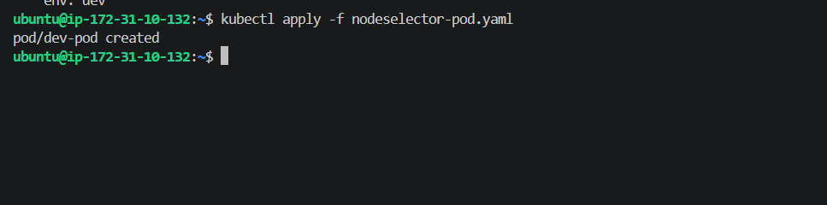
Step 3 — Verify where dev-pod is running
Run:
kubectl get pod dev-pod -o wide
We expect the NODE column to show:
ip-172-31-6-202
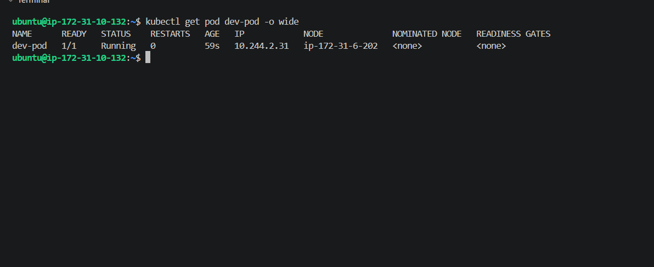
Task 4 — Step 1
Run:
kubectl label nodes ip-172-31-6-202 env=test --overwrite
Then:
kubectl get nodes --show-labels
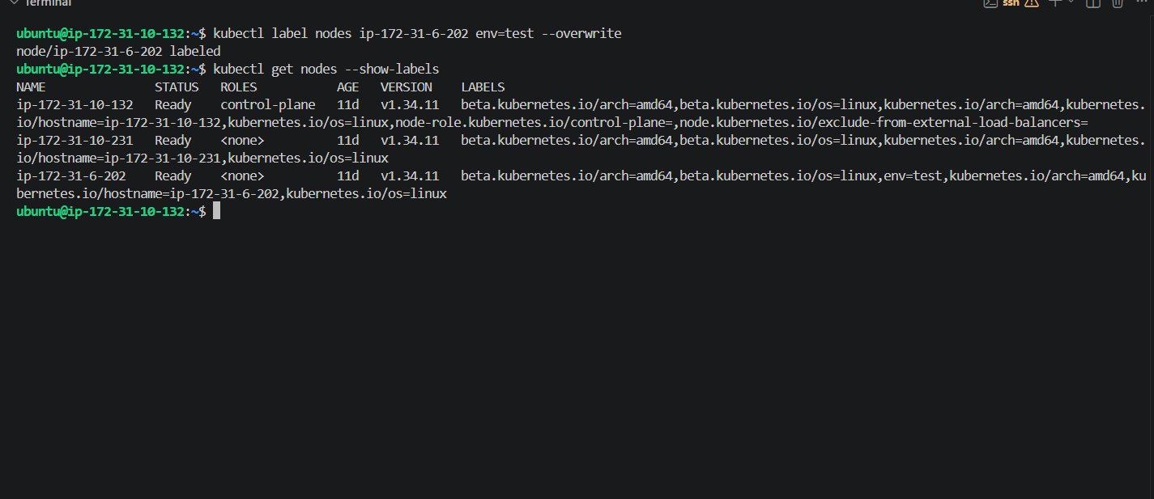
Task 4 — Step 2: Create Soft Node Affinity Pod
Run:
vi soft-affinity-pod.yaml
Paste:
apiVersion: v1
kind: Pod
metadata:
name: soft-affinity-pod
spec:
containers:
- name: nginx
image: nginx
affinity:
nodeAffinity:
preferredDuringSchedulingIgnoredDuringExecution:
- weight: 1
preference:
matchExpressions:
- key: env
operator: In
values:
- test
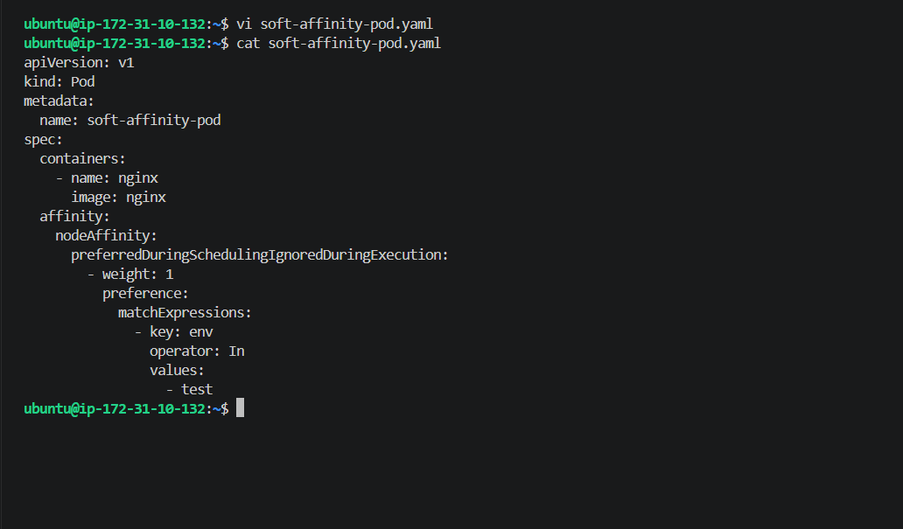
Then apply:
kubectl apply -f soft-affinity-pod.yaml
Expected:
pod/soft-affinity-pod created
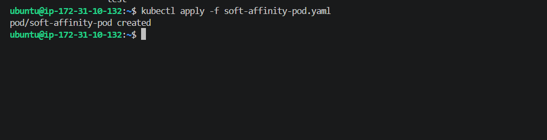
Step 3 — Check the scheduled node
Run:
kubectl get pod soft-affinity-pod -o wide
We expect the NODE column to ideally show:
ip-172-31-6-202
because that node currently has:
env=test
Run:
kubectl label nodes ip-172-31-6-202 env-
Expected:
node/ip-172-31-6-202 unlabeled
Then immediately check:
kubectl get pods -o wide
Look specifically at:
soft-affinity-pod

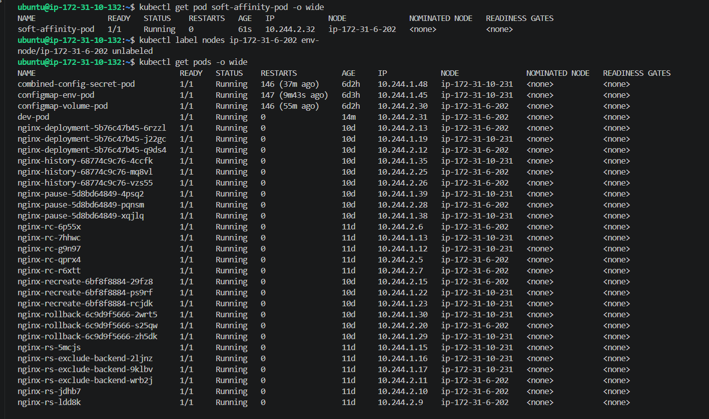
Task 5 — Hard Node Affinity
Now we're going to demonstrate the opposite behavior.
The reference requires:
Pod must run on a node with env=prod. If no node has that label, the pod should remain Pending. Kubernetes07
Step 1 — Make sure env=prod does NOT exist
Run:
kubectl get nodes --show-labels
From your current output, env=prod is not present, which is what we want.
Step 2 — Create the hard-affinity YAML
Run:
vi hard-affinity-pod.yaml
Paste:
apiVersion: v1
kind: Pod
metadata:
name: hard-affinity-pod
spec:
containers:
- name: nginx
image: nginx
affinity:
nodeAffinity:
requiredDuringSchedulingIgnoredDuringExecution:
nodeSelectorTerms:
- matchExpressions:
- key: env
operator: In
values:
- prod
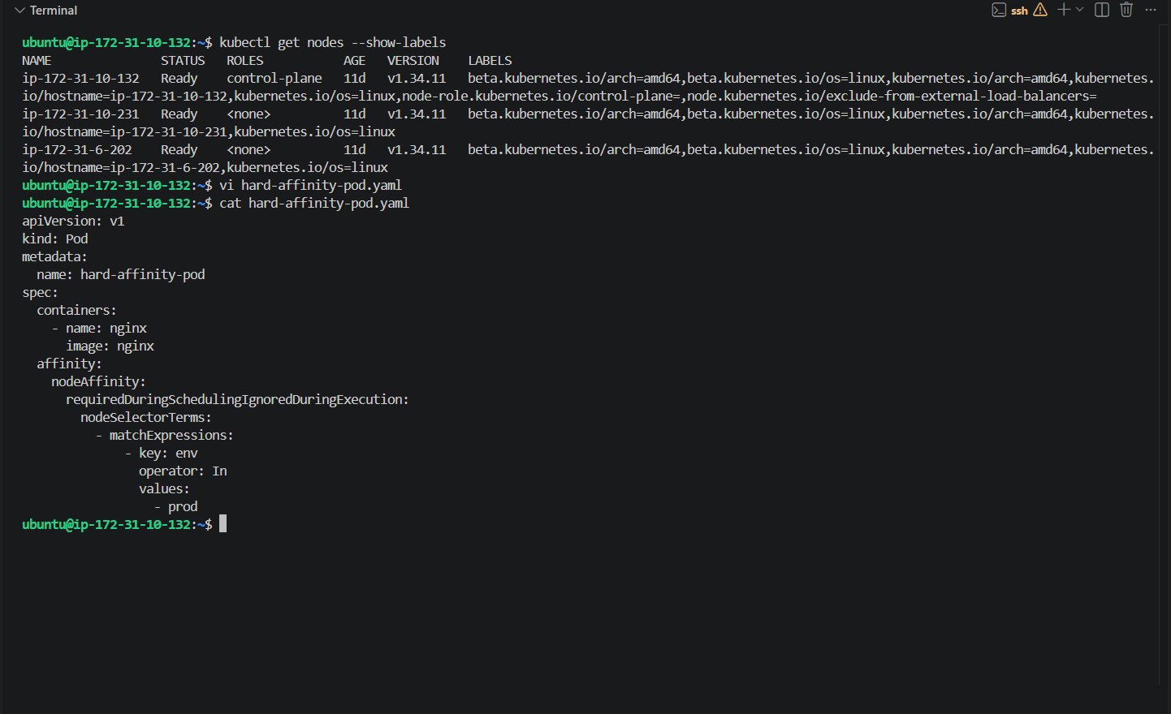
Then apply:
kubectl apply -f hard-affinity-pod.yaml
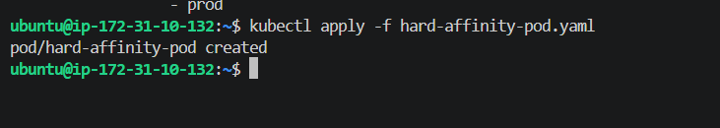

Step 3 — Verify the Pod is Pending
Run:
kubectl get pod hard-affinity-pod
Expected:
hard-affinity-pod 0/1 Pending
Then run:
kubectl describe pod hard-affinity-pod
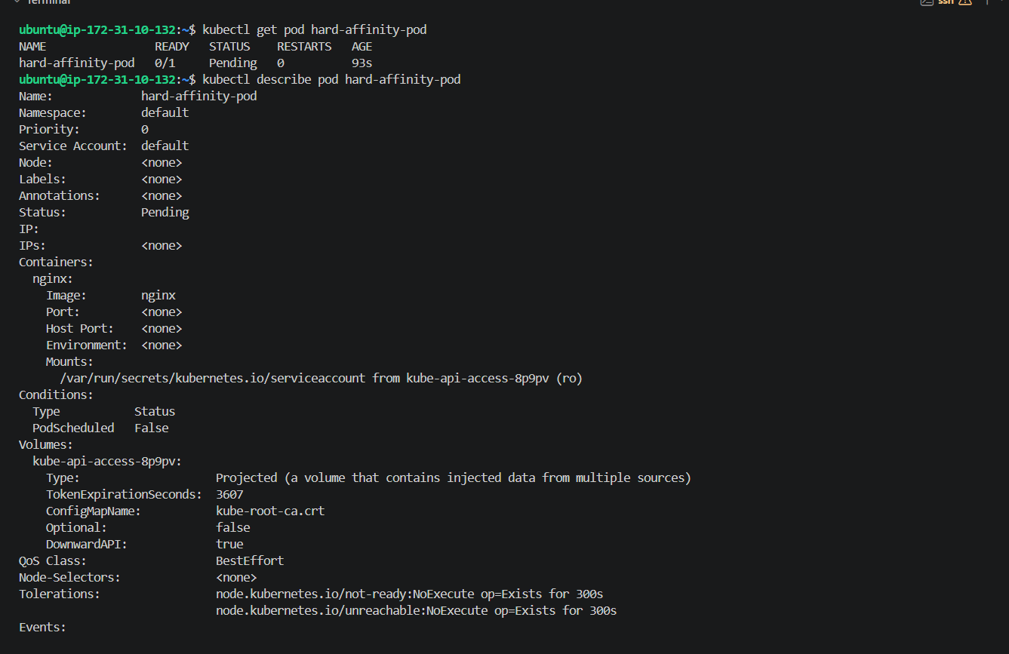
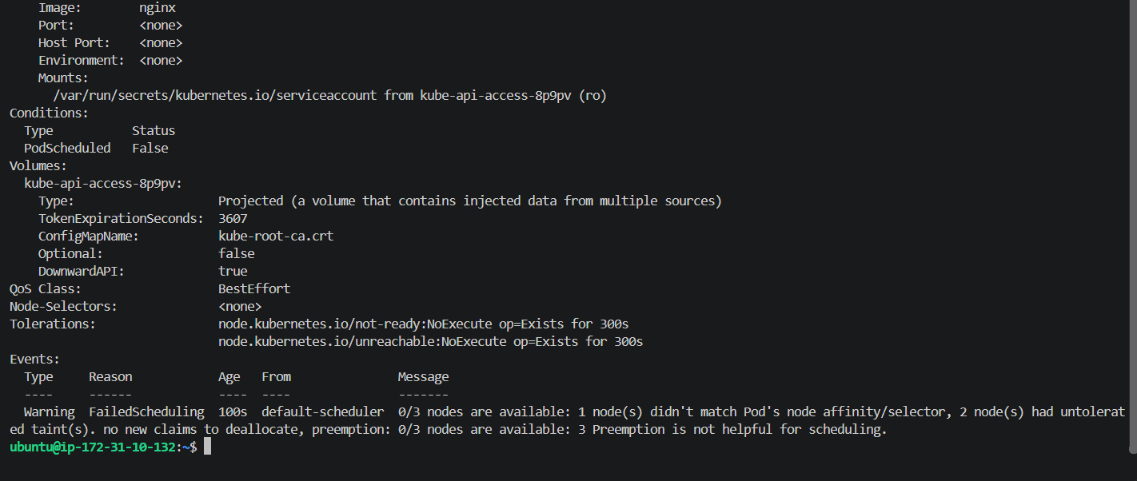
Your output proves exactly what the reference asks for.
1. Pod is Pending
hard-affinity-pod 0/1 Pending
2. Pod has not been scheduled
Node: <none>
PodScheduled: False
3. Scheduler rejected the nodes
Your event says:
0/3 nodes are available:
1 node(s) didn't match Pod's node affinity/selector,
2 node(s) had untolerated taint(s)
The important part for this task is:
didn't match Pod's node affinity/selector
Because your pod requires:
env=prod
and currently no node has env=prod.
This matches the reference's expected behavior: when no matching node exists, the hard-affinity pod stays Pending. Kubernetes07
Now let's prove the second half
We'll add env=prod to your worker:
ip-172-31-10-231
Run:
kubectl label nodes ip-172-31-10-231 env=prod
Expected:
node/ip-172-31-10-231 labeled
Then immediately run:
kubectl get pod hard-affinity-pod -o wide
We expect Kubernetes to notice that a suitable node now exists and schedule the pod onto:
ip-172-31-10-231
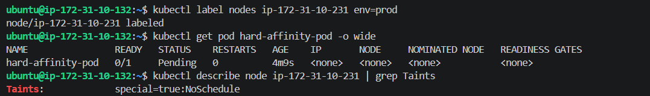
Your node has:
Taints: special=true:NoSchedule
And your hard-affinity-pod requires:
env=prod
So the node satisfies one condition but fails the other:
We need to remove the Task 2 taint
Since Task 2 is already completed and we no longer need that taint for Task 5, remove it with:
kubectl taint nodes ip-172-31-10-231 special=true:NoSchedule-
Expected:
node/ip-172-31-10-231 untainted
Then verify:
kubectl describe node ip-172-31-10-231 | grep Taints
It should show no special=true:NoSchedule taint.
Then check the hard-affinity pod:
kubectl get pod hard-affinity-pod -o wide
It should now become:
hard-affinity-pod 1/1 Running ... ip-172-31-10-231
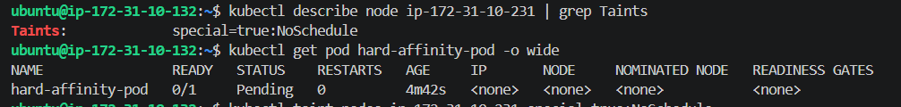
Step 5 — Check the pod again
Run:
kubectl get pod hard-affinity-pod -o wide
We expect:
hard-affinity-pod 1/1 Running ... ip-172-31-10-231
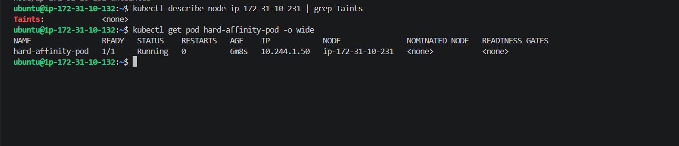
Task 5 is completely completed.
Your final output proves the complete hard-affinity behavior:
hard-affinity-pod 1/1 Running ... ip-172-31-10-231
And the node has:
Taints: <none>
The sequence was exactly what we needed:
No env=prod node
↓
hard-affinity-pod → Pending ❌
↓
Add env=prod
↓
Still Pending because of NoSchedule taint
↓
Remove the taint
↓
hard-affinity-pod → Running ✅
↓
ip-172-31-10-231
Task 6 — Step 1
First confirm:
kubectl get nodes
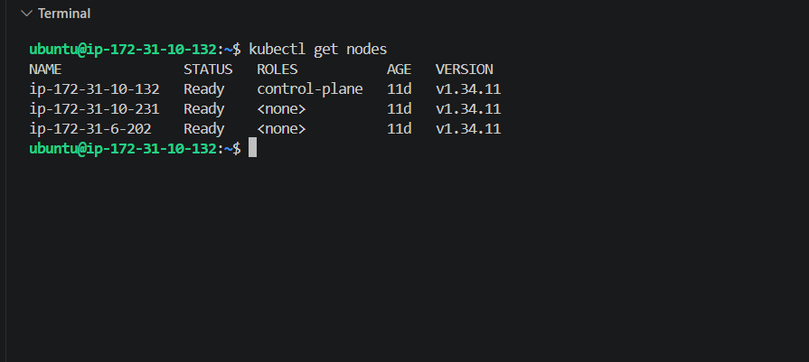
Task 6 — Step 2: Create noexecute-pod.yaml
Run:
vi noexecute-pod.yaml
Paste this:
apiVersion: v1
kind: Pod
metadata:
name: noexecute-pod
spec:
containers:
- name: nginx
image: nginx
tolerations:
- key: "special"
operator: "Equal"
value: "true"
effect: "NoExecute"
tolerationSeconds: 60
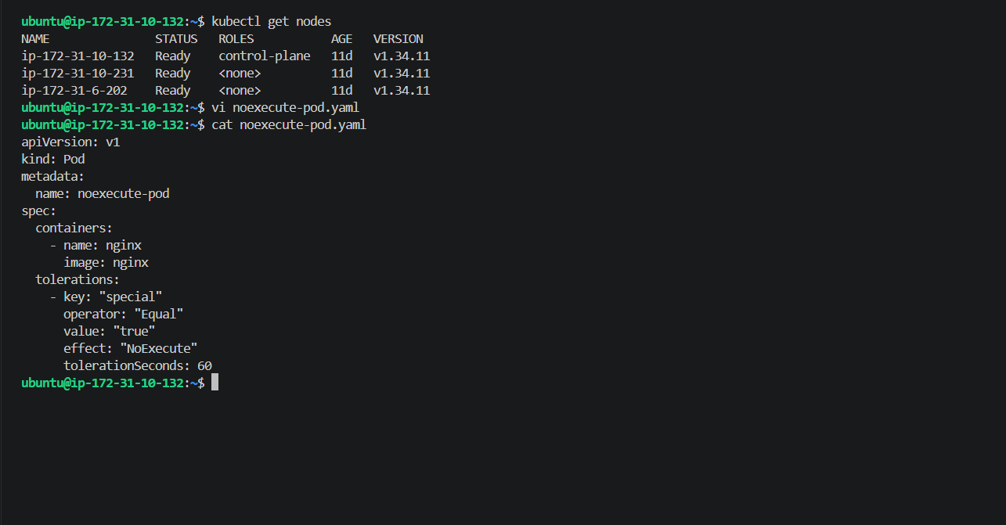
Then:
kubectl apply -f noexecute-pod.yaml
After that, do not apply the taint yet.
Run:
kubectl get pod noexecute-pod -o wide
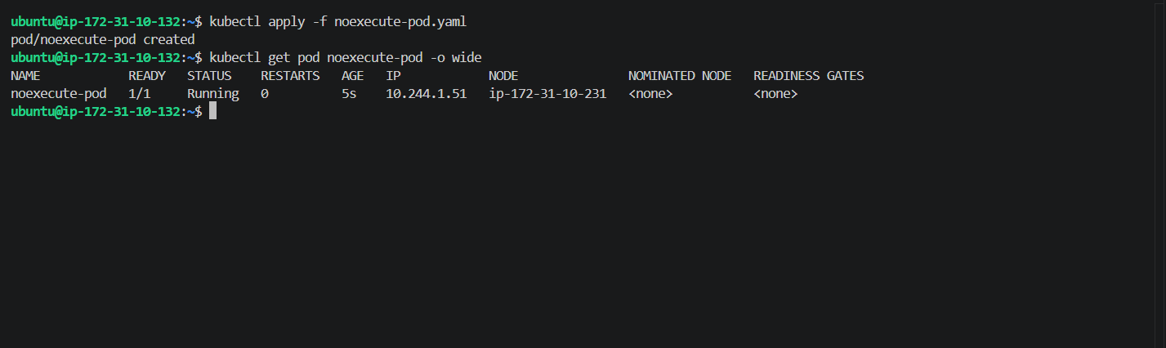
Task 6 — Step 3: Apply the NoExecute taint
Now run:
kubectl taint nodes ip-172-31-10-231 special=true:NoExecute
Expected:
node/ip-172-31-10-231 tainted
Immediately after that
Run:
kubectl get pod noexecute-pod -o wide
